**DAILY ONLINE ACTIVITIES SUMMARY**

|  |  |  |  |  |  |  |  |  |
| --- | --- | --- | --- | --- | --- | --- | --- | --- |
| **Date:** | **18/05/2020** | | | | | **Name:** | **BHAVYA.S** | |
| **Sem & Sec** | **4th SEM ‘A’ Section** | | | | | **USN:** | **4AL18CS014** | |
| **Online Test Summary** | | | | | | | | |
| **Subject** | | **Complex Analysis,Probability and Statistical Methods(18MAT41)** | | | | | | |
| **Max. Marks** | | **30** | | **Score** | | | **5** | |
| **Certification Course Summary** | | | | | | | | |
| **Course** | **Python for Machine Learning** | | | | | | | |
| **Certificate Provider** | | | **Great Learning** | | **Duration** | | | **2 Hours** |
| **Coding Challenges** | | | | | | | | |
| **Problem Statement:** **Using methods charAt() & length() of String class, write a program to print the**  **frequency of each character in a string.**  **“Hello friend”**  **Output should be**  **-: 1**  **d: 1**  **e: 2**  **f: 1**  **(continued for all character in the string)** | | | | | | | | |
| **Status: Completed** | | | | | | | | |
| **Uploaded the report in Github** | | | | | **Yes** | | | |
| **If yes Repository name** | | | | | <https://github.com/Bhavyamahadev/lockdown-coding> | | | |
| **Uploaded the report in slack** | | | | | **Yes** | | | |

CERTIFICATION COURSE DETAILS:

Python for Machine Learning: The topics covered under Python for Machine Learning are

1.Why Python,Python VS R,Python- IDEs-2

2.Anaconda installation,Introduction to Jupyter Notebook-2

3.Jupyter Notebook Shortcuts-2

4.Data Structure hands-on

5.Conditional Statement

6.Loops

7.Other Functions

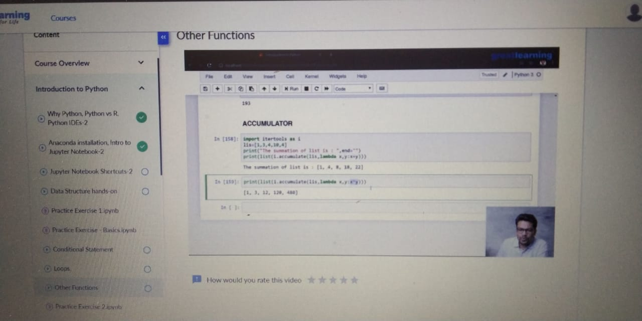

CODING CHALLENGES DETAILS:

Problem statement 1:

Using methods charAt() & length() of String class, write a program to print the

frequency of each character in a string.

“Hello friend”

Output should be

-: 1

d: 1

e: 2

f: 1

(continued for all character in the string)